Walsall Falls Prevention Learning & Development Project



**‘Growing a World-Class Workforce’**

# Evaluation of Integrated Health & Social Care Stakeholder event – 17th June 2014

Background to the project, purpose and objectives

To establish an innovative falls prevention learning and development programme for the health and social care workforce, delivered across health and social care in clinical and community settings.

The successful delivery of this pilot project will lead to improved practice and support the implementation of the falls strategy and falls pathway.

The project aims to:-

* Improve safety, quality of care, delivering better experiences for people who are at risk of falling.
* Reduce emergency admissions to hospital as a result of a fall.
* Reduce the number and severity of falls across a range of health and social care settings, including nursing and residential care homes and community settings.
* Demonstrate improved awareness, skills and knowledge in relation to falls prevention with employees in the statutory and independent health and social care sector.
* Develop the application of learning and best practice to the Frail Elderly Workforce Programme in Birmingham and the Black Country both during and upon completion of the pilot.

Aims of this report: To evaluate the Stakeholder event on 17/6/14  
One of three to be scheduled during 2014/15

* To engage and consult with providers of care, including the NHS Trust, Public Health, CCG, Walsall Council Adult Social Care & Inclusion workforce, Independent Sector Residential, Nursing Care Homes, Domiciliary Care agencies and the Voluntary Sector to design and shape a Walsall innovative falls prevention learning & development programme for the Health and Social Care workforce,
* This event provided an opportunity to consider and discuss what learning and support services are currently available? What the data is telling us around the incidence of falls? Who is most at risk? And to clarify who the workforce is?

Summary Evaluation

The event is an initial and first stage consultation with key stakeholders, one of three throughout the year to engage jointly with health, social care, and community care providers in the design and development of a ‘fit for purpose’ integrated pilot Falls Prevention Learning & Development Programme for Walsall

Sally Roberts, Lead Nurse with Walsall’s Clinical Commissioning Group (CCG) and Falls Champion along with Julian Mellor, Older Adults Workforce Integration Programme Manager; two key note speakers presented context and background to the Project (funded by the Local Education Training Board, through Health Education West Midlands).

**Consultation - Representation**

There was a fair representation of professionals in attendance working across the private, independent nursing and residential care workforce, NHS health partners, Public Health and Local Authority social care workforce. Appendix (i) – delegates list.

However, there were noticeable gaps and an absence in representation from the voluntary sector, domiciliary care providers, residential and nursing care home representatives, GP’s, carers including the Carers Centre, the Ambulance Service and individuals with family members living with the consequences and experiences of falls. A brief opportunity emerged during the event to engage with a carer, who agreed to provide personal experience from the perspective of a family member and partner experiencing frequent falls.

* **Stakeholder Analysis.** The project will complete a full stakeholder analysis to  
  continue to identify further stakeholders across all care provision to work in collaboration, consult, communicate and promote the project developments.

NB, The event was communicated to an extensive list of organisations and individuals. This evaluation report will be circulated to all those who expressed an interest in attending the event, but who were unable to commit at this stage of the Project.

**Next Steps** agreed by delegates; to continue to share information via Walsall Adult Social Care Workforce Development website and the project lead.

**Event outcome:**

* The event identified a wealth of information in terms of Falls Prevention activities, training and services within the Borough and indeed throughout the Black Country.
* Public Health is currently undertaking a strategic review of Walsall’s Falls Prevention Programme within Acute and Community settings in terms of patient pathways and preventable measures outlined in current guidance.



Integrated Health & Social Care Workforce Stakeholder Learning & Development

Event Programme – 17th June 2014

9.30am Register & Refreshments

9.45am Sally Roberts: CCG Lead Nurse

Quality Improvements and Partnerships,NHS Walsall

9.55am Julian Mellor: Programme Manager Older Adults  
 Workforce Integration Programme

10.15am Event Facilitator - Janet Lilley: Falls Prevention L&D Lead

Adult Social Care, Walsall Council

10.30am First table top activity – Explore & discuss current L&D opportunities and   
 support services in relation to falls

10.45am Second table top activity – Consider what the data is telling us around   
 the incidence of falls?

11.00am Refreshments

11.15am Third table top activity– Discuss who is most at risk of falling?

11.30am Fourth table top activity – Clarify who we think the workforce is?

**11.45am** Activities: Course ‘taster’ experience of limited vision and loss of manual   
 dexterity. A kinaesthetic perspective of someone with sight   
 deterioration & physical loss of hand/fingers functions.

**12.0Opm Summary of table top activities**

**12.10pm** Building our Brand - Group work to consider logo/straplines for project

**12.30pm** Next steps explanation i.e. network/testing

**12.45pm** Trainer Network ‘sign up

**1.00pm** Evaluation and Event Closure

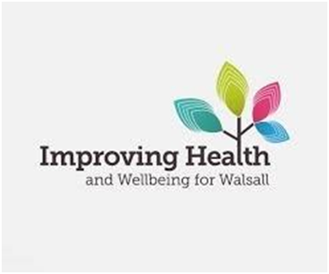**Keynote speakers**

Sally Roberts welcomed delegates to the first stakeholder event in relation to this Pilot Project to develop a patient centric ‘whole system’ based approach to workforce development to improve services and deliver health and social care reform with new models of service delivery, delivering care in the right setting, supporting the integrated care agenda and equipping staff to operate effectively in different environments.

Sally also cited 78% of residents being admitted to the acute services by West Midlands Ambulance Service from 999 calls were made by nursing homes, resulting in 3,666 bed-days. 89.8% of hospital admissions were attributable to a diagnosis of a chest infection, **falls and urinary tract infection and 38% attributed to patients who fall.**  The average length of stay for patients was 19.4 days.

Julian Mellor further outlined Walsall’s Falls Prevention Project is one of six projects being developed in Birmingham and the Black Country to evaluate the benefits from integrating Learning and development approaches, up skill staff to operate in different environments within a multidisciplinary workforce.

Additional projects include a learning and development programme for Birmingham residential care homes provided by Birmingham University Hospital.   
  
Feedback, consistency of content and best practice will be shared within projects to shape Walsall’s programme to become ‘best in class.’

Other Projects:

|  |  |
| --- | --- |
| **Project Theme** | **Lead Organisation** |
| Falls and Fractures – Care Homes | University Hospitals Birmingham NHSFT |
| Integrated Care Model | Pathfinder Healthcare Development CIC |
| Falls Prevention – Health and Social Care | Walsall Council |
| Complete Care Programme (community) | Birmingham Community Healthcare NHS Trust |
| Integrated Care and Support (GP’s) | Solihull CCG |
| Competency Based Education and Training Programme – Care Homes | Shropshire CCG |

Walsall aims to test out a programme across a multi-disciplinary workforce, to develop further knowledge, awareness and the skills to develop best practice.

**Table top activities facilitated by key Health & Social Care personnel: Appendices ii – v.**

* Who is the workforce? Appendix ii - Steph Charles Workforce Development Walsall Council
* Who is most at risk? Appendix iii – Janet Lilley Workforce Development Walsall Council
* What is the data is telling us? Appendix iv – Richard Tipper Patient Safety NHS Trust
* What Learning and development resources and support services are currently available? Appendix v – Anita Hughes NHS Trust

**Learning & Development – Table top activity –** Appendix (v)

This table top activity showcased the Walsall NHS Trust’s Falls Awareness learning (1 day event), which is available to the Independent Sector and Walsall Council workforce. There is also a programme for NHS personnel internally within the acute hospital setting.

Since the commencement of the project and the event, The Trusts Falls Prevention Awareness Training to “reduce the numbers of falls which result in serious injury and ensure effective treatment and rehabilitation of those who have fallen,”(standard 6 – National Service Framework for older people), has been refreshed, to be delivered to the Independent Sector and non- NHS staff including Walsall Council Social Care workforce.

All feedback and further evaluation of the NHS Trust’s course with impact on learning is being collated to support the design of a Walsall integrated programme to include the development of an E Learning Programme available through Walsall Adult Social Care & Inclusion

There has been some further successful delivery of training through Falls Co-ordinators based in Wolverhampton, Dudley and Sandwell;

Further scoping of Learning and Development provided by other Local Authorities within the Black Country is ongoing and will support the shaping of Walsall’s design.

**Walsall Falls Prevention Services**

There is a specialist **Community Falls team** based at Hollybank House, Willenhall, consisting of Nurses, a Physiotherapist, an Occupational Therapist and a Technical Instructor, working in the community to reduce the risk of further falls by offering support, advice and guidance with referral to a specialist falls Consultant.

**Walsall’s Leisure, sports & Community Services provides** a **Falls and Balance Programme**, a specialised 22 week exercise programme for people who are at moderate risk of falls (at least one fall in a year), which includes a brief multi-factorial assessment and a further ‘Active Steps’ specialised exercise programme for people who are at risk or frightened of falling.

Both programmes are led by qualified Postural Stability Instructors and designed to reduce people’s risks of falling by improving posture, balance, mobility and strengthening bones particularly the hip, wrist and spine.

* This Falls Learning & Development Pilot Project will continue to collaborate with the NHS Trust, the Community Falls Team, Public Health and stakeholders in the design of any Learning & Development Programme, so that services are effectively signposted.

Appendix (v) also refers to additional post event feedback from the ‘training’ table top activity with firm evidence highlighting; ‘falls awareness is a subject that **all roles and all levels of staff** should have knowledge and confidence with’.

**What the data is telling us? – Table Top Activity –** Appendix iv

This table top activity considered; What data is available and what does it tell us? The discussions led to questioning –is it reliable?

**The data is ‘overwhelming, misleading with different settings having different   
 requirements’.** *(source comment from delegate)*

**No of Older People in Walsall is projected to increase by 12.9% (2021)**

**Hip Fracture Rate per 100,000: Walsall Compared to West Midlands and England**

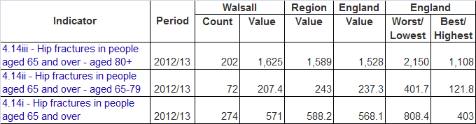

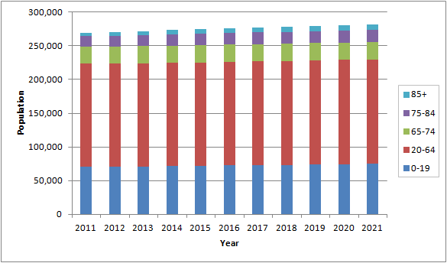

The table shows that in 2012/13 274 of Walsall older residents (>65 Years) who had a Hip Fracture – 202 of these were aged over 80 Years

The overall rate for Walsall is 571 per 100,000 compare to the regional average of 588 per 100,000 and England average of 568 per 100,000

**Walsall NHS Trust - Patient Safety Acute setting – Data/intelligence   
What is this telling us?**

* In **2012/13**, almost 1000 falls were reported in the acute hospital setting.
* 16 serious falls events where a fall led to a serious injury.

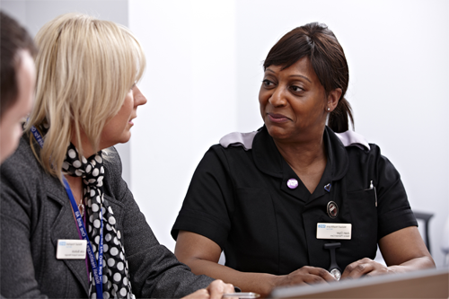

* In **2013/14** , total 536 falls recorded.
* A **43%** reduction in falls compared to the previous year.
* Data representing 3.31 falls per 1000 bed days.   
   (source NHS Trust)

The Trust has undertaken significant programmes of work to accomplish these improvements which have included, but are not limited to the recruitment of well-being apprentices to support the supervision of patients. There has also been the purchase of specialist equipment to respond to individual needs of patients including chair and bed sensor alarms, low beds and tilting chairs.

**With these and other interventions, there has been a steady controlled reduction in falls over the year.**

* Peer auditing procedures have increased ownership and accountability at local levels.
* Improving documentation and assessment reliability/consistency.
* Staffing

It is estimated that patient slips, trips and falls cost the NHS approximately £15 million per year nationally. Using a range of simple interventions; research has shown a reduction in the number of patient accidents recorded nationally and evident with Walsall’s programme within the hospital wards.

**This table top activity presented:-**

* The number of older people in Walsall will increase by 2021 from 46,095 (2011) to 52,062 (2021). Further the number of people 85 yrs and older increasing from 5,467 (2008) to 8,109 (2021).
* Older people are at greatest risk of falling and suffering permanent injury as a result of a fall. Hip fractures in Walsall sit just slightly under the national average.
* The planning needs of a growing number of older people must be incorporated within key strategic priorities in Walsall. (source Public Health Strategic Review).
* 78% of residents being admitted to the acute services by West Midlands Ambulance Service from 999 calls are made by nursing homes - diagnosis **falls and urinary tract infection and 38% attributed to patients who fall.**  (source WMAS/CCG)

This table top activity concluded that data recorded locally is not particularly shared across Health & Social Care.

**The sources however need to continue to be monitored**;

WMAS, Public Health, NHS Trust/hospital admissions data, will inform the L&D programme, for example, the project will be able to target awareness training specifically in care/nursing homes, with ‘preventable’ interventions/ measures working in collaboration with (WMAS), West Midlands Ambulance Service & Walsall Falls Service following this stakeholder engagement event.

**Who is most at risk? – Table top activity -** Appendix iii

This activity explored the wider picture in terms of who may be at risk of a fall?

**Everyone can be at risk.** Depending on their individual circumstances particularly where there is an existing medical condition leading to balance issues, dizziness. For example, anyone living with a diagnosis of epilepsy at any age. Young or old.

However, particularly older adults:-

* Those prescribed several medicines – a need for regular medication review.
* The diagnosis of medical conditions especially those with urinary tract infections resulting in frequent need to urinate recorded by WMAS with 999 calls, specifically from nursing care homes resulting in possible preventable hospital emergency admissions.
* Those who have already experienced a fall, being particularly susceptible and especially where the fall has resulted in a hip fracture.
* Those with any recent surgery
* Poor assessment – no assessment in the use of walking aids/wheelchair use
* Women with osteoporosis – premature menopause.

**All consistent with national data and intelligence.**

Additional feedback following the event for this table top activity:-

* One delegate would like to consult further on the issues or gaps within a falls service what may be missing?
* One way to consult further: to recommend an anonymous survey to stakeholders to capture this information.

**Who is the workforce?** **- Table top activity** - Appendix ii

This table top activity produced an extensive workforce list; professional roles, individuals **internally** within the Council Social Care & Inclusion workforce, ie intermediate care at home services with reablement officers, social workers, safeguarding adults and wider within the Council for example – Highways, environmental, community & Leisure services.

The **external workforce** considered roles within the Community and hospital acute (ward) settings: paramedics, the range of personnel listed included clinical/qualified nursing personnel, GP’s dieticians, chiropractors, mental health services, residential/nursing care, bus drivers, carers and family members.

Event agreed next steps:

**Event Participants agreed:** Continue sharing information byemail from Project Lead  
Workforce Development Website, organisations, council, NHS Trust to share information at team meetings.  
  
**Trainers Network:** An invitation email will be sent to those who ‘signed up.’

Project proposed Next steps:

Broadly – timeline Gantt chart to be reviewed: July to end September 2014

* Work with Public Health to analyse current intelligence on the incidence of falls to inform and target learning and development programmes.
* Identification of other data sources
* Mapping and preliminary evaluation of current training and development activities in relation to falls prevention
* Completion of stakeholder analysis
* Develop Trainers Network
* Test a Walsall L&D Programme
* Develop E Learning Programme
* Develop application ie ‘Healthy House’ – Hazards and checklist for personal safety
* Public Awareness Campaign
* Decide Logo/Strapline

Who attended 26 attendees Appendix (i)

Speakers: Sally Roberts: CCG Lead Nurse   
 Quality improvements and Partnerships, NHS Walsall   
 Julian Mellor: Programme Manager   
 Older Adults Workforce Integration Programme  
  
 Janet Lilley: Development Consultant - Falls Prevention Project  
 Walsall Council workforce development Adult Social Care & Inclusion

Facilitators: Richard Tipper: Patient Safety Project Manager  
 Walsall Healthcare NHS Trust  
 Juanita Hughes: Falls Trainer – Independent Sector  
 Walsall NHS Trust  
 Steph Charles: Training Officer  
 Walsall Council Adult Social Care & Inclusion Workforce   
 Development  
 Elaine Delaney: Programme Office  
 Walsall Council Adult Social Care & Inclusion

Janet Lilley: Falls Prevention Programme Lead Learning & Development  
 Workforce Development ASC&I Falls Project

Delegates: Sue Hanson: Area Manager Community Intermediate Care Service ASC&I  
 C. Beckwirth: Falls & Balance Nurse  
 J. Bagley: Unit Manager  
 Adam Biggs: Health Emergency Planning  
 Lisa Koc: Service Manager Workforce Development ASC&I  
 Janette Healey: Clinical lead (Community)

Christine Brown: Senior Reablement Officer

Charlotte Mills: Health & Social Care Apprentice

Asif Hussain: Health & Social Care Apprentice

Natasha Hincks: Well Being Apprentice Walsall NHS Trust

Harriet Pickford: Well Being Apprentice Walsall NHS Trust

Lynn Jones: Project office Walsall Council Adult Services

Ann Pasme: Community Falls Nurse

Sarah Richards: Community Falls Nurse

Tina Mason: Provider -Registered Manager Cedar Falls Residential Home

J. Tachar: Provider – Owner Cedar Falls Residential Home

M Barton: Senior Carer Angel Court Residential Care Home

M. Matthews: Senior Carer: Angel Court Residential Care Home

Appendix (ii)

# Who is the Workforce?

Table Top Activity – Who is our Workforce? – Facilitator Steph Charles

|  |  |  |
| --- | --- | --- |
| **INTERNAL** | **EXTERNAL** |  |
| **AACM:**  Social Work Teams  Safeguarding  OT’s | A.S.G. Unit |  |
| Apprentices | Acute trust |  |
| Bus Drivers | Admin staff |  |
| Caretakers / Curators | Advocates |  |
| Clean & Green (Grit) | Ambulance / paramedics |  |
| Commissioning / JCU | ASU |  |
| H&S Committee | Banks |  |
| H&S Training Officer | Care Quality Commission |  |
| Highways | Chiropodist |  |
| HR (Policy/procedures) | Chiropractor |  |
| ILC | Community mental health |  |
| Key Workers | Community Nurses |  |
| Leisure Services | Community Organisations:   * Church * Over 60’s clubs |  |
| NCO’s | Community transport |  |
| **Providers Services**:  Integrated Intermediate Bed Based Team (Holly Bank) Day Opportunities and Employment  Respite (Fallings Health)  Community Integrated Care Team | Contracts and monitoring |  |
| **INTERNAL** | **EXTERNAL** | **EXTERNAL** (cont) |
| +Public Health | Crisis Team | Security Staff |
| Reablement Officer | Dieticians | Ring & ride |
| Registered Managers | District Nurse | Shop workers |
| Strategic Leads / Senior Management Team | Doctors | Support groups |
| Support Officers | Domestic / catering staff | Universal Services |
| Supported Housing  Extra Care Housing | E.H.O. | Voluntary agencies i.e. Age Concern |
| WHT – Falls Team, Steering Falls Meeting | Entertainers |  |
| Workforce Development | External trainers |  |
|  | Falls Nurse |  |
|  | Family |  |
|  | FEP |  |
|  | Friends |  |
|  | Housing Associations |  |
|  | ICT/Rapid Response |  |
|  | Maintenance contractors |  |
|  | Matrons |  |
|  | MSC – Bone & Health (CCG Star Groups) |  |
|  | Neighbours |  |
|  | Nursing home staff |  |
|  | Occupational Therapists |  |
|  | Opticians |  |
|  | Outsourced HR |  |
|  | PA’s |  |
|  | Physiotherapists |  |
|  | Private carers |  |
|  | Public Health |  |
|  | Registered Providers |  |
|  | Residential home staff |  |

Appendix (iii)

# Who is at Risk?

Table Top Activity – Who is at Risk – Why? – Facilitator Janet Lilley

|  |  |  |
| --- | --- | --- |
| Who is at risk? | Who is at risk? - Discussion | Why? |
| Everyone  Old and Young and LD. Mental incapacity | **Discussions generated:** Not clear with links ie Risk of falls with alcohol/drug misuse and early with good health as advance into older years ie activity, diet and good bone health – also aware of older population ie grandparents hydration etc ... | Health conditions  Those living with Epilepsy, Parkinson’s, sight loss, Hypertension, osteoporosis, arthritis Uneven footpaths  And current ‘thrill seekers’ jumping on/over buildings/ into rivers |
| People living with degree of dementia    And especially at night – prone to wandering | Young people – schools education Education around Telecare – assist with falls prevention  Educate families  Tutor/support staff to be trained – At Risk with individuals  Awareness sessions ie diet, | Especially with sight impairment: Need different colour plate to eat from (not white) some homes changed toilet seat to blue |
| Those with drug/alcohol misuse Medication users – dosage/changes side effects | Falls service don’t want dementia referrals from residential care homes– question why? | Effects of poor lifestyle, the differing drugs and side effects |
| Evidence of risk in elderly  People sliding off bed  Those who use Walking aids, stick |  | More prone to falls whilst working in the garden, shopping and rushing about |
| Wheel Chair Users |  | Not fit due to incorrect or no assessment  Pt’s perception/capabilities |

Appendix (iv)

# What the data is telling us?

Table Top Activity – What is the data telling us – Facilitator Richard Tipper

Housing Groups – do they have data?  
Data – problems with GP’s – How do we tackle them?  
Regional comparisors – Are we comparing apples with apples?

Data targeting & show effective outcomes

Is data shared  
who asks the questions?

Evidence reliability  
Data is reliable in places, but may be less so elsewhere  
Sharing info – how do we take on board what is gathered externally  
The story behind the data – staff/buildings/sharing/communication

Individual behaviour – what do we need to share?

Data from   
hospital, gp/family/discharge

Overwhelming, misleading, cannot see the wood for the trees – Different settings have different requirements  
Different settings – does the data give us all the lessons?  
Co-incidence or correlation

Rugs, wires – This is me?

Trends  
Minimise/reduce/why  
Apprentice working with patients who are identified 12hr shifts

Enough staff – make falls part of Induction

Recorded? Unless it is serious  
Pre morbid stats  
Social Environment  
Communication – What don’t we know?  
Detail? Audit – going deeper in to stats  
National guidance?   
family, medicine, falls  
Bathroom falls seek assistance  
T shirts ‘I’m not too busy to......’

Stroke wards amu – assessment

‘Call before you fall’

# What does the current learning, training look like?

Appendix (v)

Table Top Activity – What does the current training look like? – Facilitator   
 Anita Hughes

What do we need to include?

**Training table**

Residential Setting

No Falls Training

Falls Team _ Referral to Dartmouth House

Prognosis – Dementia – excluded from falls prevention

Training: Injuries

Lack of Mobility

Changes Lifestyle

Causes Risk assessment

Signs

Meetings

**Training Table**

Policies

Data

Risk

Signposting Services

Reporting

Notification

Falls study

1 day

Ward sessions

Bupa – falls training induction

Mental Health – Risk Assessment

Patient handling – mandatory

E learning – refresher

Learning styles - all levels

Spot hazards – responsibilities

Apps spot hazard

ILC Ipads

Interactive

Short and sweet

Updates

Not full session

CQC specialist training

Exercise

Data myths

Dementia

Diet practical

Training evaluation meetings (3 meetings) how putting into practice

Who why when, setting info

Real legislation – responsibility liability

Scenarios

Share real falls experience

Bed rails

Training

Dementia

Dols/MCA

Morse tools

Exercise balance programme (22 week course)

No longer have transport – massive impact

Apprentice – Walsall council

No falls training

Works with young adults

Table Top Activity – What does the current training look like? – Facilitator   
 Anita Hughes

Additional feedback from table activities.

* Data for Falls in care homes
* Sign posting to all services
* Individual falls policy guidance
* Who and when to notify authorities of falls
* Dementia
* Diet
* Environmental risks
* Severity of injuries
* Psychological and physical impact of a fall
* Courses should be short and enjoyable whilst having an eye opening experience – Practical activities/In the patient’s shoes.
* Courses should be structured to include all levels of learning requirements.
* Falls awareness is a subject that all roles and all levels of staff should have knowledge and confidence with.
* We should not have to wait for a competent member of staff to be present to prevent a fall or, to attend to a fall – (First aider responsibilities should be made clear in the organisations policy).
* All levels of staff should be aware of each other’s responsibilities/boundaries.  
  - This can then promote team work. Personal development and, whistle blowing.
* Falls training should be in the same category as manual handling and health and safety (mandatory). It is a health and safety issue throughout.
* Falls training should be mandatory for any services caring for people at medium or high level of risk.
* CQC should inspect training records for falls as well as falls/incident data.
* More one-one social support should be available for people with a high risk of falls (not a sitting service).
* Bed rails should not be in place for people who can get out of bed independently - even if they are at risk of falling once they are out...
* The care home staff who attended the stakeholder event were concerned that they had not received training in falls awareness.

Appendix (vi)

Branding – Logo Activity – Delegates were asked to consider a Project logo and strapline:



Staying Steady

Steady Steps

Striking a Balance

Don’t Fall it’s your

**C**autious

**A**ctive

**L**ive Well

**L**earn

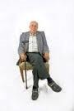



**Trip**

**Slip**

**Prevent**

**F** ocus

**A** ware

**L** ifestyle

**L** earn

**Prevent**

**Happy**

**Feet**

**Active Staff**



**Achieving a Balance**

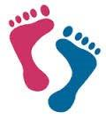

**ILC**



**Falls**

**Change**

**Safe**



Delegates Evaluation Appendix (vii)

9 Event evaluation Forms Completed

Delegate quote:

* Workshops productive – each table captured good information
* Delegates learning from each other’s roles and responsibilities
* Connecting areas that cover falls which they didn’t know before

1. What are your objectives for attending this Course?

* To increase knowledge in Falls Prevention and to meet other people with an interest in Falls Prevention
* To learn more about Falls, reasons, at risk groups, data, who’s targeted for learning
* Knowledge of all sectors provision for Falls Prevention
* To learn more about Falls Prevention
* To learn more about Falls Prevention, measure of falls
* To learn more about Falls Prevention and provide details of my job role
* Find out how we can take this forward
* To hear from various workforce, carers, families views, thoughts and experiences about training on falls or around falls who is at risk and why what the data is telling us i.e. if falls are preventable
* Facilitation and learn more about the Falls initiative

2. Do you think this session met your objectives?  
Participants were asked to select Yes or No

3. Was the session presented/delivered  
Participants were asked to select Excellent, Good, Average or Poor

1. How useful were the activities during the session and did the trainer provide sufficient opportunities for participation? What was of benefit to you?

* Activities very good, able to put views forward and listen to views of others
* Good – Enjoyed World Cafe
* Helped to identify how the physical impairment leads to fall
* Bit rushed, but good
* Ample, able to share and gain information
* The activities gave me all the information I needed and gave me chance to explain my job role
* Gave insight to problems that disabled live
* Yes, full participation with facilitated World Cafe Workshops
* Good – Lots of participation and table work. Learned more about the size of the work involved

1. Are there any comments you would like to make that could improve the session?

* More time, more room
* More time, better parking facilities
* Room too small. Sign up? To become a trainer?
* Consider size and venue, organisation and PowerPoint’s prior to the event

1. Please quote me. Here’s a sentence (or two) on my experience of the session and what impact it has had on me.

* A very good listening curve – More aware of the number of people involved
* Helped to improve knowledge
* Given me more information on Falls Prevention
* Glad to see others taking an active part to move and find solutions and cascade
* Very good, huge impact
* Very interesting and motivating
* An opportunity to hear, speak to people who work with or have experienced the effects of a fall
* Excited to see the finished product and roll out
* Extent of work and who it effects

1. Please provide details of any contacts you may have that may be interested in the Falls Prevention initiative.

* Carers Centre
* Ambulance Service
* Admissions People at A&E
* Housing 21

**A FINAL NOTE OF THANKS: To Elaine Delaney – Project Office Adult Social Care & Inclusion for ‘The Wall’, co-designing specific falls resources and administration with project events.**

Resources development for stakeholders & Workforce Development Website

**[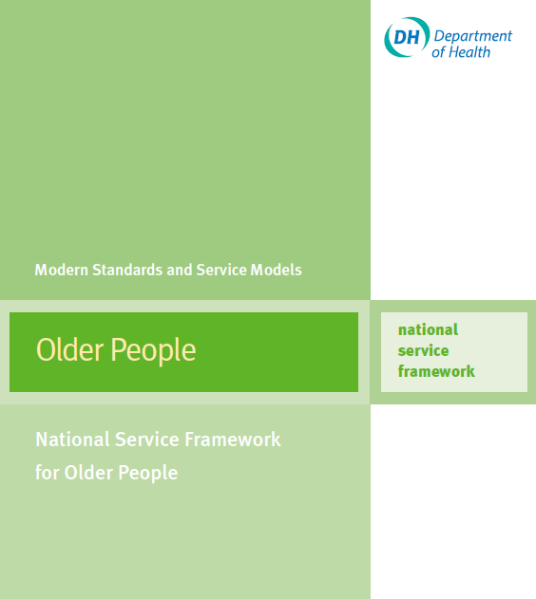](https://www.gov.uk/government/uploads/system/uploads/attachment_data/file/198033/National_Service_Framework_for_Older_People.pdf)[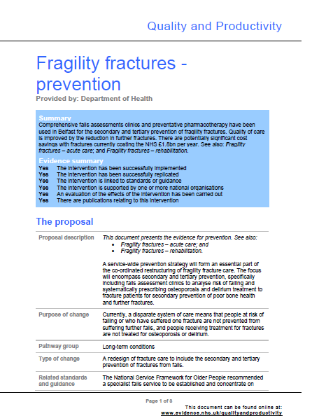](https://www.google.co.uk/url?sa=t&rct=j&q=&esrc=s&source=web&cd=12&ved=0CGwQFjAL&url=https://arms.evidence.nhs.uk/resources/qipp/29465/attachment&ei=vXrWU4_FK6iL7Ab7rYGwBw&usg=AFQjCNGT1HG29AI8cWcM1wj938HVs96wVg&bvm=bv.71778758,d.ZWU)[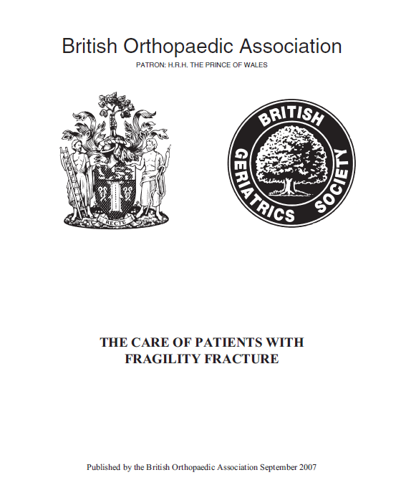](http://www.bgs.org.uk/pdf_cms/pubs/Blue%20Book%20on%20fragility%20fracture%20care.pdf)[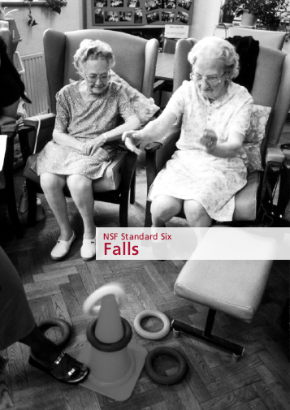](http://www.sepho.org.uk/Download/Public/6212/1/8%20NSF%20standard%206.pdf)**

# Integrated Health & Social Care Improving safety, quality of care, deliver better experiences for people who are at risk of falling, reduce emergency admissions to hospital as a result of a fall.

***“We know that if we follow the evidence, we can substantially reduce the number of falls and fractures, thereby increasing health and well-being and reducing the cost to the system”*Norman Lamb MP, Minister of State for Care and Support**

[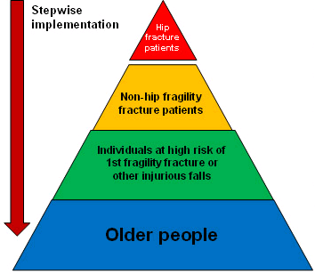](http://www.osteoporosis-resources.org.uk/identification/4-what-should-our-priorities-be)[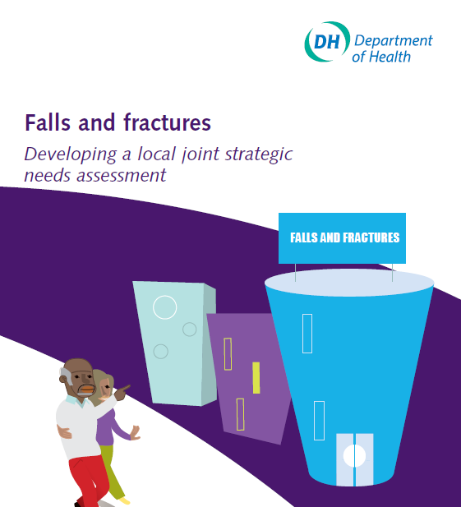](http://webarchive.nationalarchives.gov.uk/20130107105354/http:/www.dh.gov.uk/prod_consum_dh/groups/dh_digitalassets/@dh/@en/@pg/documents/digitalasset/dh_103147.pdf)[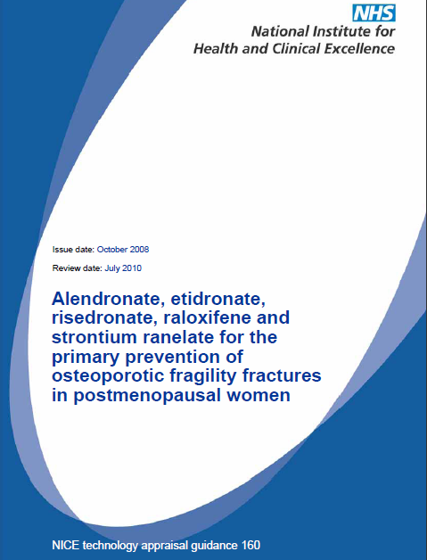](http://www.nice.org.uk/guidance/ta160/resources/ta160-osteoporosis-primary-prevention-understanding-nice-guidance2)

Janet Lilley: Falls Prevention Project Lead  
 Website: [*www.walsallsocialcareworkforce.co.uk*](http://www.walsallsocialcareworkforce.co.uk)

Email: *workforcedevelopment@walsall.gov.uk*

Telephone*: 01922 655541*